This document contains proprietary information on a product under development by Fullplay Media Systems, Inc. The information contained herein is not to be used by or disclosed to third parties without the express written permission of Fullplay Media Systems, Inc. Fullplay Media Systems, Inc. reserves the right to make changes to this specification and the products described herein at any time without notice. The purchase or use of the product from Fullplay Media Systems, Inc. does not convey a license under any patent rights, copyrights, trademarks or any other intellectual property rights of Fullplay Media Systems, Inc.

Copyright © 2002, by Fullplay Media Systems, Inc. All rights reserved.

Sahara Design Verification Test

Program Manager | Kenn Gordon
Manager | Dave Proctor
Engineer | Josh Kelly
Testers | Josh Kelly, Bruce Wollen
File Name | Sahara_Design_Verification_Test.doc

Revision History
Latest Revision | Date
Document Created | 10-01-02

Purpose
To Specify a set of tests to verify the design of the Fullplay Meda Systems, Sahara Darwin Juke Box design, and to record the results of those tests.

Functional Blocks
The functional blocks tested were: Audio out, Audio in, Software Mute, Digital Audio out, Ethernet, IDE, Memory, Reset, Software Reset, Serial, Power Supply, Display, Buttons, IR.

Test Equipment
The following equipment was used for the DVT:
- Tektronix TDS3034 Oscilloscope.
- Fluke 87 III Digital Multimeter
- Audio Precision ATS2 Audio Test Set.
- Toshiba Satellite Laptop PC running ATS2 Software
- Test PC using Tera Term Serial Terminal Software
- Monster Cable RCA Coaxial Audio cable
- Toslink Optical Cable
- Generic RCA Coaxial Audio Cable
- Audio Test CD

Analog Audio Out
Using the application software on the Darwin Jukebox DUT, with the DUT attached to the audio Precision Analyzer (ATS2) with the monster cables, These tests were done with no weighting filter, and with a pass band of 22Hz to 20kHz:

A 0dB, -20dB, and –50dB 997Hz sine wave from the test Cd was used for the THD + N measurements. The results of the THD+N and the Dynamic range tests are recorded in table 1. The FFT dBV-vs-Frequency for a 997hz sine wave at 0db showing the Fundamental frequency and the resulting harmonics can be seen in figure 1. The 42L50 Spec’s –83dB Thd+N at 0dB, but the CDB42L50 (42L50 Evaluation Board) tested to –77.0dB THD+N and a –91.0dB Dynamic Range. The interchannel gain mismatch is within the +/- 0.05V of error that can be induced by resistor tolerances in the output circuit. With a noise level of –92dBV while when the DAC is off, and a full-scale amplitude of +6dBV, the signal to noise ratio is -98dBV.

Output Level | Right 1.943VRMS | Left 1.967VRMS
THD+N @ 0db 997Hz | Right –79.4dB | Left –78.9dB
THD+N @ -20db 1kHz | Right –69.8dB | Left –68.9dB
THD+N @ -50db 1kHz | Right –39.8dB | Left –39.9dB
SMPTE IMD @ 0dB | Right –73.9dB | Left –74.9dB
Dynamic Range | Right –89.8dB | Left –89.9dB
Table 1.Analog Audio Harmonic Distortion and Noise

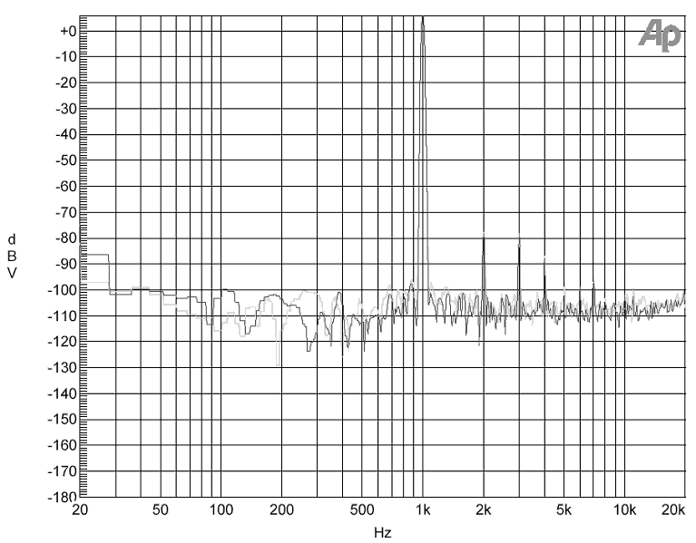
Figure 1. 997Hz FFT dBV –vs- Frequency

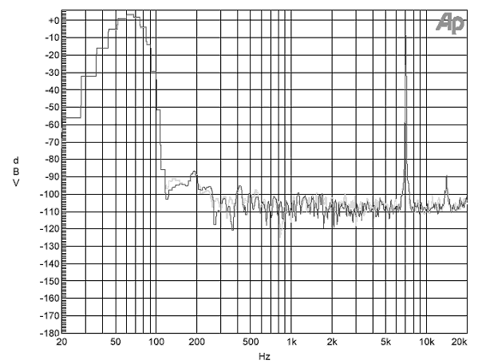
Figure 2. SMPTE 7KHz 63Hz FFT dBV-vs-Frequency Showing Intermodulation Distortion

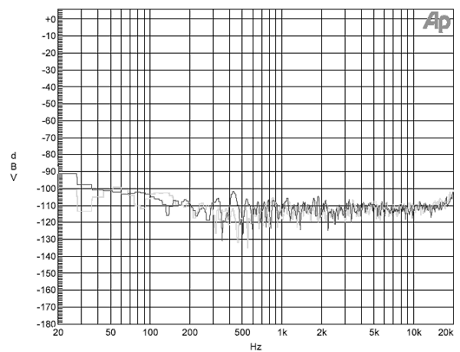
Figure 3. FFT dBV-vs-Frequency of a quiet tone, showing noise.

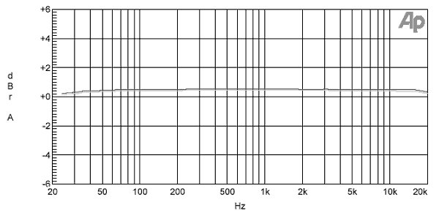
Figure 4. 20Hz to 20kHz frequency response.

Audio In
The same tests were run to test the audio out, but looped through the 42L50 using the ATS2 as the audio source. Some additional tests were run as well, as the test suites were available for the ATS2 audio generator. These tests give insight into the performance of the output, as well as the input of the DUT. The tests were run using the Func90.bin test software and the ADC test. The input signal was set to 2VRMS, at this level the Max Counts were 31971 and the Clip Bit registered 0. The THD+N results are shown in table 2.

Output Level | Right 1.921 | Left 1.898
THD+N @ +6.022dBV | Right -77.695dB | Left -77.596dB
THD+N @ -20dBV | Right -57.696dB | Left -57.406dB
THD+N @ -40dBV | Right -37.909dB | Left -37.416dB
Table 2. THD+N Loop Through.
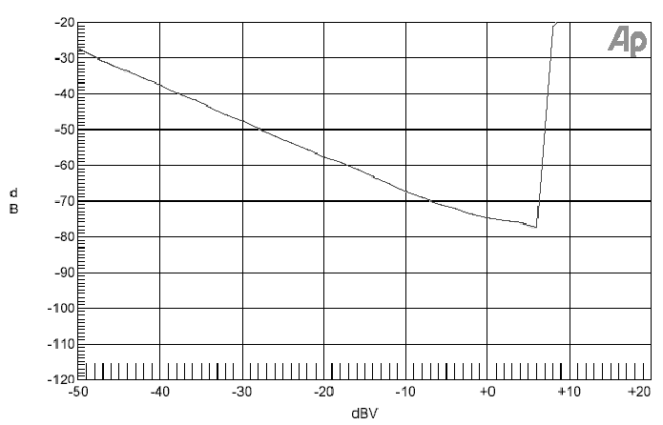
Figure 5 THD + N -vs- Amplitude Loop Through

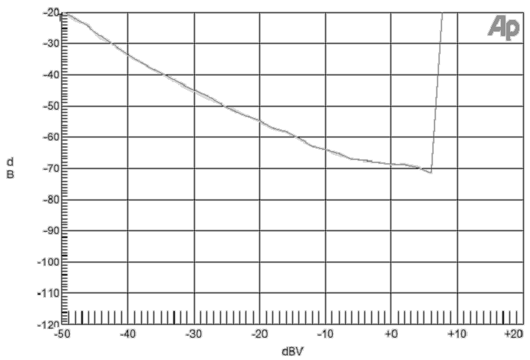
Figure 6. SMPTE IMD vs. Amplitude - Loop through

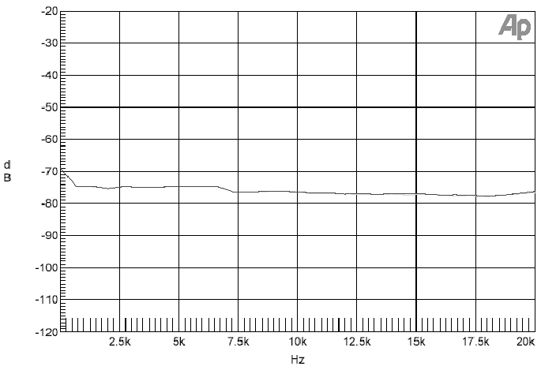
Figure 7. THD+N vs. Frequency – Loop Through

Audio Mute
In the functional test, the audio mute was turned on by the command “GPIO D 2 1 1” . With the input at 2VRMS the muted Output Level was 85mV (-21.485dBV)

Digital Audio Out
The S/PDIF output was connected to the to the ATS2 with a 3 foot Toslink cable. The graphs from the ATS2 show the behavior of the D/PDIF digital audio interface. The Eye diagram in figure 8 gives a quick estimate of the quality of the signal, while Figure 9 shows the section of the actual waveform being transmitted by the DUT. Figure 10 shows the time domain view of the jitter, the peak jitter seems to be about +/- 500ps, but the jitter analyzer reported 239ps of jitter. Figure 11 show the frequency spectrum of S/PDIF jitter from the Darwin Jukebox DUT. The probability distribution of the jitter amplitude is shown in figure 12. Figures 13 and 14 show the probabilities for the pulse amplitude and pulse width respectively. These tests show that the waveform is good, and that the jitter is well under the 1nS max spec for the CS8405.

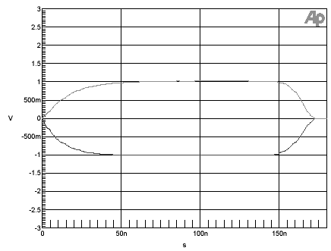

Figure 8. S/PDIF Eye Pattern
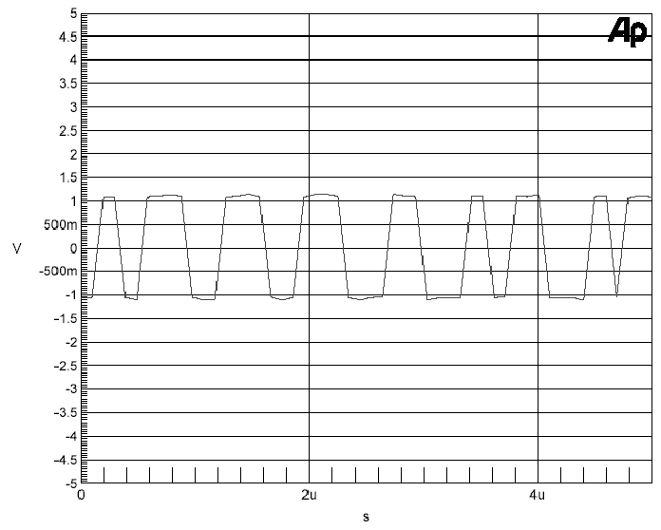
Figure 9. S/PDIF Waveform
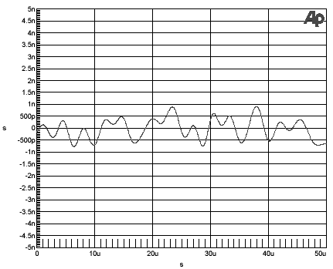
Figure 10. S/PDIF Jitter

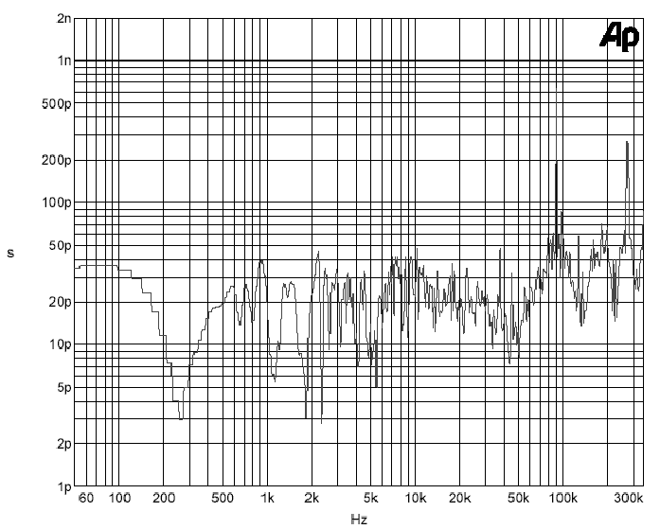
Figure 11. S/PDIF Jitter vs. Frequency
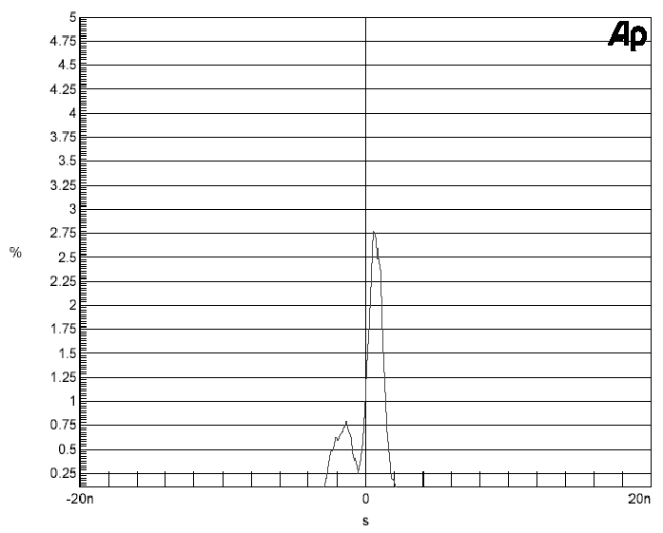
Figure 12. Jitter Histogram
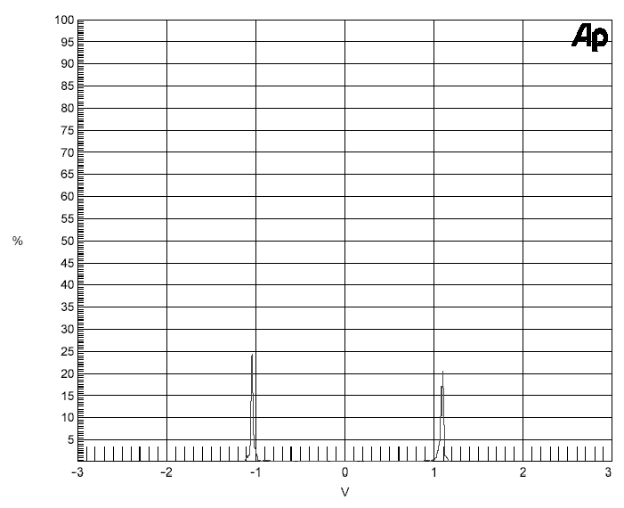
Figure 13. S/PDIF Jitter Amplitude Histogram
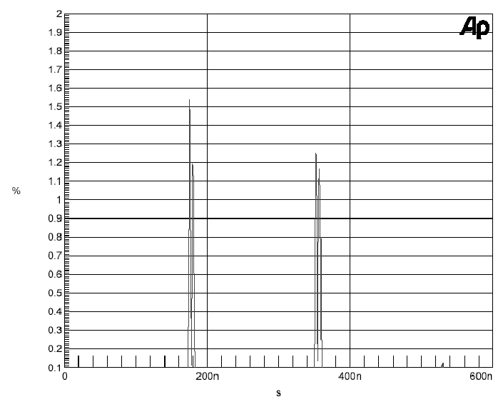
Figure 14. S/PDIF Pulse width Histogram

Ethernet
With a Cat 5 cable connected to J8, and to a network, the NET test Passed: Net Send, 688.17 b/s Net Receive, 711.11 b/s.
Address, data, chip select are within spec for the CS8900A. Refer to Document DJ-C40 Device Timing for the timing specs for Darwin Jukebox Ethernet.

IDE

The ATA CD Test Passed and the ATA HD Test Passed. The timings were within Spec.
Refer to Document DJ-C40 Device Timing for the timing specs for the ATA bus. The termination resistors are correct to the ATA spec with the exception of INTRQ and IORDY. IORDY does not need a termination in POI mode, and since INTRQ goes to the CPLD which is level sensitive, a termination is not necessary for INTRQ either. If we choose to use UDMA modes in the future these signals will have to be terminated with an 82 Ohm series resistor.

Memory
Memtest_Set and Memtest_Orig were run over night, there were no failures.
Refer to Document DJ-C40 Device Timing for the SDRAM timings.

Reset
Reset is held low for 350ms after the reset button is released, and when the GPIO PD0 is set in the Functionality test.

Serial

Using the current functionality test exercised the serial port at 57600 baud and the DUT passed the serial test. The serial port was also run at 9600 baud in the Application.

Power Supply
The 12V power supply was attached to the dummy load and tested up to 3.7A . The +5V and +3.3V were tested with the CD and hard drive spinning.
+12 @ Load, 11.99V Ripple, <80mA
+5V @ load, 4.93V
+3.3V, 3.305V
+2.5V, 2.50V
A+3.3V, 3.299V
A+10V, 9.99V

Display
The display test was run in the functionality test all pixels operated properly, and there were no alignment or flicker problems. The display was also observed in the application with no problems. Refer to Document DJ-C40 Device Timing for the timing specs for the LCD bus.

Buttons
The key test was run with no errors.

Infra Red Receiver
The IR test was run with no errors.

Conclusion
The results of the tests performed showed that the Darwin Jukebox hardware design performs as expected.

